HIGHLANDS
SURGERY
1643 London Road
Leigh on Sea
Essex
SS9 2SQ

Telephone 01702 710131
Fax 01702 471154

Website:
www.highlandsurgery.co.uk
Reception email: reception.mailboxf81112@nhs.net
Prescription email:
meds.f81112@nhs.net

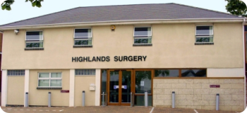
Welcome to Highlands Surgery
Our Practice leaflet offers you information and services available at Highlands Surgery.

This leaflet and more information are available on our website at www.highlandsurgery.co.uk
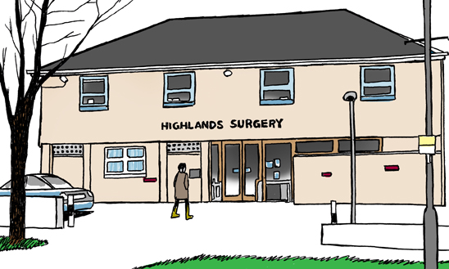

Highlands Surgery
History

The practice was established in the 1970’s and was originally situated at Walker Drive Leigh on Sea. The Surgery then moved to the now Highlands Branch Site.

The surgery moved into its current location at 1643 London Road on 15th October 1993.

We currently have just over 13,500 patients and continue to grow. The Surgery has 3 Partners, 2 Salaried GP’s 4 Nurses and 2 HCA’s.

We also have associated to our surgery Community District Nurses, Health Visitors, Social Prescribers, Musculoskeletal Specialist, Clinical Pharmacist and Proactive Advanced Care Team.

Our Patient Participation Group meets regularly and from time to time, works with the practice to arrange information events. These have been very well received and more are planned for the future.

OPENING HOURS

Telephones 8:00 am to 6:30 pm Mon - Fri

Doors open 8:00 am to 6:00 pm Mon - Fri

Website

All the information held within this booklet is
available on our website at www.highlandsurgery.co.uk.

Our Team

Doctors
- Dr Shaw
- Dr Huynh
- Dr Ozturk
- Dr Boyce

Reception
- Gintare
- Suzie
- Tracey
- Justine
- Emma
- Annabelle
- Sarah
- Sally
- Chris
- Julie

Management
- Katie – Practice Manager
- Carrie – Practice Support Manager
- Izabela – Patient Services Manager

Admin staff
- Natasha – Finance Administrator
- Molly – Business Administrator
- Tina – Administrator
- Denise- Administrator
- Janice – Administrator
- Maxine – Secretary
- Dawn – Administrator
- Lucy – Prescription Clerk
- Josh – Prescription Clerk
- Silvi – Prescription Clerk
Nurses
- Lisa – Practice Nurse
- Hilary– Practice Nurse
- Angela– Practice Nurse
- Amy– Practice Nurse

HCA’s
- Jill
- Claire

General Information

Appointments
How can I book an appointment?
Telephone – 01702 710131
Online – To set up an online account visit our website www.highlandsurgery.co.uk

How does your appointment system work?
Our GPs and Managers have personally trained our front of house Reception team who will signpost your call. To assist us in your call you may be asked to disclose personal information to allow us to decide the best way to deal with your concern quickly.
Providing us with this information allows us to determine the appropriate pathway to follow for your individual concern.
For example, it may be better for you to see a Nurse in the first instance. There is always a Doctor available for the Nurse to contact if she is concerned about the problem.
This could be;
- Advice from the GP relayed through our experienced Reception team;
- A telephone call back from the GP within 24 hours;
- An appointment with a Nurse, there is always a Doctor available for the Nurse to contact if she is concerned about the problem;
- An appointment with a GP.

What types of appointments are available?
Routine Non-Urgent appointments
Routine pre-bookable appointments are available on line and released on line at 8:00am each working day.
Appointments can be booked, online or by telephone.
All appointments are strictly for one Patient.

Emergency Appointments
If you have a problem that has developed overnight or worsened during the previous 24 hours, telephone the surgery as soon as you can after 8am.
Our Reception team will triage your call to decide the best way to deal with your concern quickly.
If an emergency appointment is required you will be offered an appointment during or after morning surgery.
This appointment may not be with your preferred practitioner but the next available or duty doctor.

Home Visits
We visit only patients who are housebound or too ill to attend the surgery. If you require a home visit please call the practice before 10.30 am. Please be prepared to explain why a home visit is necessary as this helps the doctor triage requests.
Cancellation of appointments
How do I cancel my appointment?
If you know you are unable to keep your appointment please contact the surgery to enable us to offer this appointment to another patient.
Call us on 01702 710131
Email us at reception.mailboxf81112@nhs.net with your appointment details and name.
Reply “Cancel” to the text appointment reminder 24hr prior to the appointment.

Repeat prescriptions
How can I request my repeat prescription?
Requests for repeat prescription can be made;
Online – To set up online services please visit: http://www.highlandsurgery.co.uk
Can I order over the telephone?
Repeat Prescriptions by Voice Connect please register by contacting reception on 01702 710131.
Repeat prescription orders by telephone are accepted by calling 01702 710131 Option 2. Please only use this service in an emergency or if you are unable to order via online or by Voice Connect.

What is the Electronic Prescribing Service (EPS)?
EPS allows us to send your prescription(s) directly to your chosen pharmacy electronically. If you would like to set this up please speak to your Pharmacist or let us know.
Out of Hours
If you need urgent medical treatment when the surgery is closed please telephone the surgery on the usual number and wait to be connected to the out of hours service. Alternatively dial 111 or visit www.nhs.uk/111 where you can access health advice and information.
Test Results
We do not routinely phone patients with test results unless medication is urgently needed. It is your responsibility to call to check on your results. Please call after 2.00pm and before 5.00pm. Please allow up to 5 days for test results to be received unless otherwise specified by your GP.
Travel Vaccinations
Patients should download Travel Immunisation Form from Highlands Surgery website, complete and return to the practice. Forms will take around 5 working days for the Nurse to complete. Appointments are booked routinely at around 4 weeks. You are advised to complete a course of travel vaccinations at least 2 weeks prior to travelling. If you require urgent vaccinations, it would be advised to seek advice from a travel clinic.
Joining the Practice
New Patients
How do I join the Practice?
If you would like to apply to register at Highlands Surgery, please visit our website www.highlandsurgery.co.uk and complete the registration form as directed.
Once you receive confirmation of your registration you can and arrange a New Patient Appointment with one of the Practice Nurses.
Catchment Area
As a guide our catchment area extends down to Southbourne Grove Westcliff up to Hadleigh roundabout please check our catchment area on our website.
What if I move outside of your catchment area?
We have a mandated requirement to be able to provide appropriate clinical response to our patients at their place of residence. If a patient moves out of the designated practice area, they will be requested to register with a new GP.
We are aware that there may be some circumstances where such a patient may wish to justify their retention with the Practice and if this is the case they may write to the Practice Manager. The registration will be assessed by the Partnership on a safety basis for your continued care.
We also reserve the right to remove patients from our list under the following circumstances;
- Where a patient has moved abroad for a period of 3 months of more.
- Where a patient fails to attend pre-booked appointments on a number of occasions.
- Where there is an irretrievable breakdown of the Doctor-Patient Relationship.
Temporary Resident
You can be registered as a temporary patient for up to three months. Temporary registration can be arranged by simply contacting the practice. You cannot register as a temporary patient if your permanent place of residence and surgery are in the local area. Temporary registration is for immediate and necessary treatment only and not routine screening.
Personal Details
If you change your name, address, telephone number (including mobile), email address or key code, please complete a change of details form which you can obtain from our website www.highlandsurgery.co.uk or email reception.mailboxf81112@nhs.net and let our reception staff know immediately.
It is extremely important to keep your details up to date in case of an emergency. If you move outside the practice boundary it will be necessary for you to find a new general practitioner, we will not be able to provide an adequate service for you (home visits). The Clinical Commissioning Group can help you if you are having difficulty in locating a new doctor.
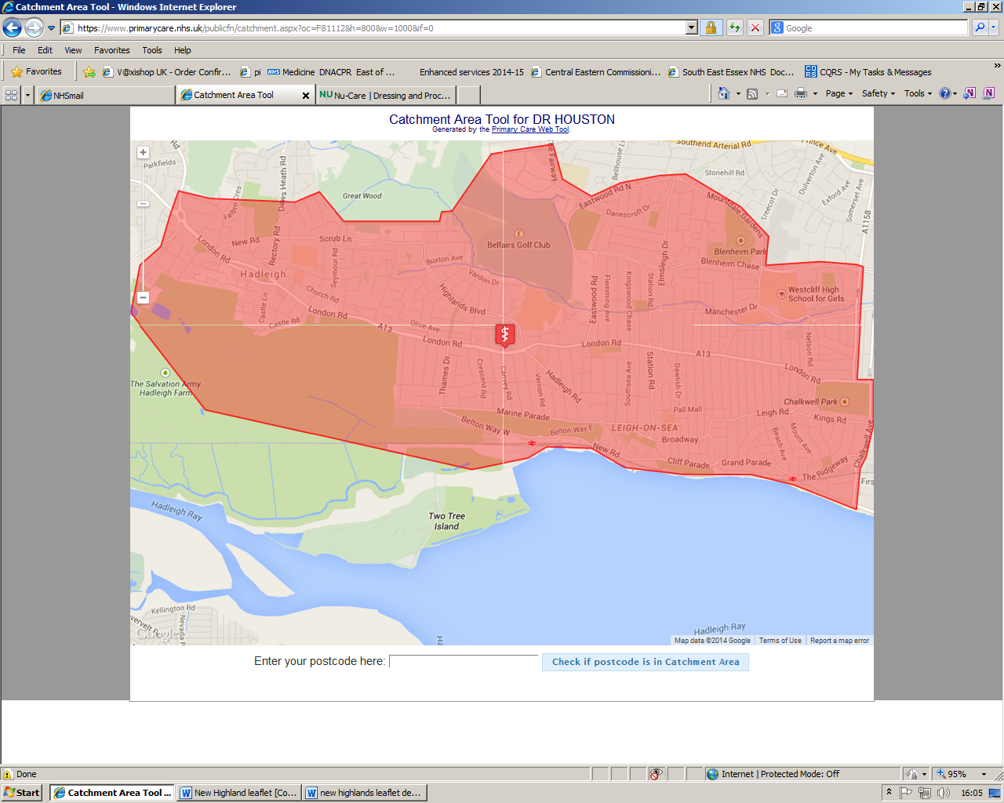
Additional Information

Disabled Access
The Surgery is well equipped for the disabled; wheelchair access is via the front door. A lift is provided for consultations on the first floor and a disabled toilet is situated on the ground floor. A wheelchair is also available from reception and a disabled parking space is allocated by the front door.
Violence
In common with the rest of the NHS we operate a zero tolerance policy on any issues of abuse whether verbal or physical on any member of staff or person on the premises. We have the right to remove a patient from our list and to inform the police of any such incident.
Time to Learn
On every first Tuesday of the month, with the exception of January and August, the surgery will be closed for the afternoon from 13:00pm. During this time the clinical and admin staff will be attending sessions for development and updates of their professional skills.
Fees for non NHS services
Most of the services offered by the practice are free under the NHS. Some services are not covered under the NHS and for these your GP, like other professionals, can charge a fee. The fee will reflect both the doctor’s time to carry out the service and the doctor’s professional opinion. It may also include the cost of nursing, secretarial support, stationery and consumables.
Complaints procedure
We strive at all times to provide a service of the highest standard. If you wish to make a comment or complaint, this should be made to the Practice Support Manager initially in writing. You will receive an initial response within 10 days. A full written response will be offered. If you are unhappy at that point, you can arrange to come in and discuss the problem further with a doctor and/or Practice Support Manager.
Data Protection and confidentiality
The surgery is registered with the Data Protection Agency. All patient information is stored on our computer system and is managed in accordance with national guidelines. The computer is used during consultations as it enables us to keep records up to date and helps to maintain an efficient register of all our patients. Our surgery team always work to ensure that patient information is managed to the highest standard of confidentiality. All staff complete annual Information Governance training and sign a confidentiality agreement.

Patient Participation Group (PPG)
What is a PPG?
A PPG is made up of patients and practice staff who communicate at regular intervals to discuss ways of making a positive contribution to the services and facilities offered by their Practice to patients.
When do Highlands Surgery PPG meet?
The last Tuesday of every month at 12:30 at The Estuary Club (Opposite the Practice)
What is the PPG’s aim?
We aim to contribute to the continuous improvement of the Highlands Surgery service by fostering improved communication between patients and practice. We are not political or strategic but we do like to be kept informed of changes within the NHS that affect us all, taking the wider view in relation to the delivery of primary care and the commissioning of those services.
How can I participate?
Firstly, let us know your email address so you can be added to our Virtual PPG (VPPG). This means you will receive a small number of emails per month which include the agenda of our next upcoming PPG meeting and the minutes.
You can then pop along to one of our PPG meetings. We are a very friendly bunch and welcome new members.
Or you can send us an email with any ideas or concerns and we will discuss anything relevant at our next meeting. p.referencegroup@nhs.net
For further information please visit http://www.highlandsurgery.nhs.uk/patient-group/
Do you have a newsletter?
The practice and PPG work together on the production of a quarterly newsletter; the purpose of which is to update patients, their carers and families about services at Highlands Surgery, the NHS in general or NHS issues that have an impact, and appropriate local or national service provision or initiatives, e.g. the Expert Patient Programme or Health Walks.

Practice Charter

What the Practice Will Do for You
Treat you with respect and courtesy. Undertake to see you promptly and where a delay occurs, provide an explanation of the cause. Give the most appropriate care and to refer to other services as required. Offer an urgent appointment for an acute problem as explained in the Practice Leaflet and Website. If permanently housebound or have an acute illness which makes a patient totally confined to bed and attendance at surgery is impossible a home visit may be requested as explained in the Practice Leaflet and Website. Subject to the limitations of the law and in consultation with your GP give access to your health records. Give a full and prompt reply to any complaints about the practice, its staff, and the overall performance and service.

What You Can Do for the Practice
- Treat the Practice Staff with respect and courtesy.
- Keep surgery appointments promptly and cancel appointments as early as possible if you cannot attend.
- Do not request an emergency appointment for a matter that is known not to be urgent.
- Request out of hours visits only if/when appropriate and necessary.
- Only ask for a home visit when the patient is permanently housebound or have an acute illness which totally confines them to bed.
- Allow time for Clinical and Administration staff to deal with enquiries.
- Inform the Practice of changes to your personal details e.g. change of address, name or telephone numbers and provide formal documentation to support name changes.

USEFUL TELEPHONE NUMBERS

Highlands Surgery number 01702 710131

Southend Hospital 01702 435555
Basildon Hospital 01268 524900
Thorpedene Clinic 01702 578800
Wellesley Hospital 01702 462944

Drug and Alcohol Services 01702 431889
Health Authority Clacton 01255 226050
NHS 111 111
Social Services (Southend) 01702 215000
Local Mental Health Crisis Team 111
Citizens Advice Bureau (Southend) 01702 610610
RELATE (Marriage Counselling) 01702 342901
Samaritans 0330 094 5717
AIDS Helpline 01702 215008
Age Concern 0800 678 1602
ChildLine 0800 1111
National Childbirth Trust 01268 420816
Southend-on-Sea Borough Council 01702 215000
Out of Hours Emergencies 0845 850 2783
Coroner's Office 0333 013 5000
Patient Advice and Liaison Service (PALS) 0800 0857 935
Fairhavens 01702 344879
M.S. Society of Great Britain 0808 800 8000
Smoking - National Helpline 0800 169 0169
Southend Smoking Cessation Service 01702 212000
Stroke Association 020 7566 0300
Respite Service 01702 534631
Parkinson's Disease Society 0808 800 0303
Alzheimer's Society 0845 3000 336
MacMillen Cancer Support Line Service 0808 808 00 00

